Creating Your Circle of Influence
If you are like me, the thought of going to a networking event, especially a virtual one, sends you into a slight panic. It seems like a stressful thing to do and a huge waste of time, right?

Think about it. When was the last time you went to a networking meeting and found a solid lead for a new job or found someone who actually made a difference to help you get that promotion?

But everyone says it is crucial for your career, so a couple times a year, you drum up the courage to get out there and network, only to find out that you were right! You introduce yourself to one person after another, tell them what you do, ask them what they do, exchange business cards and then nothing happens. It is a stressful experience that produces little results.

Stop wasting your time trying to network the old, uncomfortable, and ineffective way. Instead, approach building your network as building your own Circle of Influence: a group of people who are there to support your success and your dreams.

Use this template to establish a strategic networking plan that results in developing a circle of influence that supports you achieving a long-lasting, fulfilling career.

3 Steps to a Successful Strategic Networking Plan

Step One: Define your Career Vision.
Where do you want to be and what do you want to be doing within your career in 1 year and 5 years?

Step Two: Identify WHO you want in your Network.
If you could waive your magic wand and have a robust circle of influence + a healthy extended network, what type of people would be included? Who would add value to support your career aspirations?

Step Three: My Communication Plan.
Beneficial relationships require effort. Time and energy are a precious commodity therefore proper planning will ensure that you support your three different circles of influence within your network with efficiency and effectiveness.

Strategic Networking Plan, example
Step One: Define your Career Vision.
Who are you and where are you going? Get present to the unique value that you bring to the organization you choose to lend your talents. Create your 1- and 5-year career goals. If you know the exact title and location of your ideal role, state it. If you don’t, that is ok. Paint the picture by describing the role and location with the details that are important to you.

What is my unique value?
Example:
- I see talent immediately and know how to coach someone to bring out their best.
- I bring focus, efficiency and accuracy to every project which is why my projects are on time and in budget.
- I have strong communication skills. I am able to talk to people at various levels within an organization and am able to successfully navigate through tough conversations.

1 Year Vision: Where and what do I want to be doing in my career in 1 year?
Example specific: Lead Program Manager within the Government Sector living in Austin, TX.

5 Year Vision: Where and what do I want to be doing in my career in 5 year?
Example painting a picture: Working in the D&I sector using my coaching and leadership skills with the opportunity to grow into leading direct reports. Open to relocation. Want a place that has 4 seasons, is within 2 hours of a beach or large body of water and close to an International airport.

Step Two: Identify WHO you want in your Network.
Rather than attending one networking meeting after another looking for anyone who might have a lead to help you get to your goals, get strategic so you can attract people who will add value within your circle of influence.

Spend quality time brainstorming here. For each circle, ask the following questions:
a.) Who is currently in each circle of your network?

b.) Who else (or what type of person) needs to be added in your network to support your career goals?

If you could waive your magic wand to produce a valuable network that supports your career goals, who would add value to support your career aspirations within each circle? If you get stuck, go to page 12 to reference the Forbes list of types of people to include in my network.

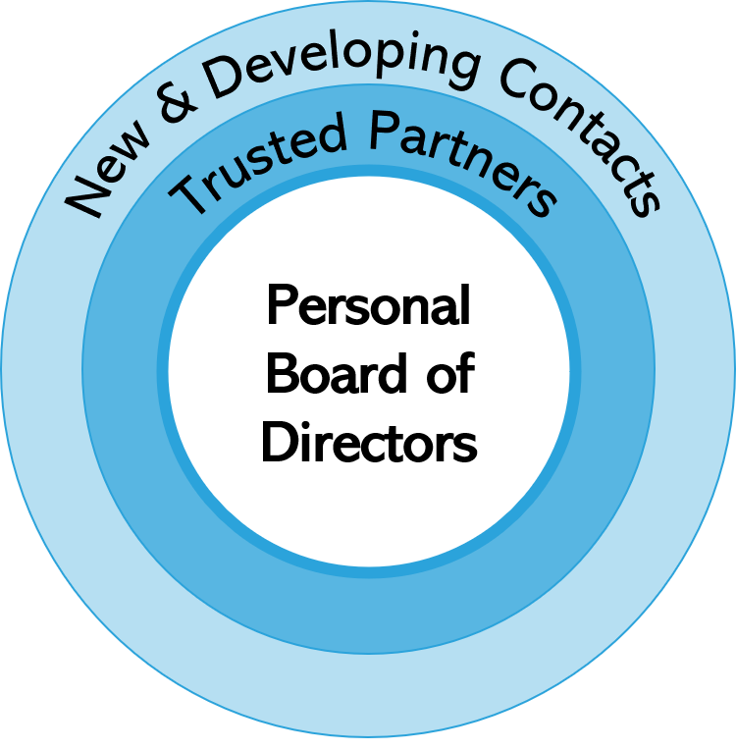
New & Developing Contact
# of Contacts:
Example: 500

Types of Contacts:
Example:
large portion is AT&T colleagues and others that I have met
Industry Insiders and Trendsetters
…

Who else would it be beneficial to include in my overall Circle of Influence?
Example: Need contacts outside of AT&T.

Trusted Partners
# of Contacts:
Example: ~ 100

Types of Contacts:
Example:
large portion is AT&T colleagues
Family, Friends, Mentors
…

Who else would it be beneficial to include in my Group of Trusted Advisors?
Example:
Contacts in my industry outside of AT&T
Connector in my field of work.
Up & Comer.

Personal Board of Directors
- List out everyone who is in your PBoD.
Example:
Coach – Name(s)
Mentor – Name(s)
Sponsor – Name(s)
Advisor – Name(s)
Partner – Name(s)
…

- Gap Analysis. Are there any gaps? Begin seeking out people who can fill the gaps. Are you spending time, effort and energy on contacts that aren’t giving back? Move those out of your Personal BoD.

Example:
Connector, Coach for Public Speaking.

BONUS: Not sure if someone should be included within your inner circle? Conduct the Circle of Influence Personal Board of Director Evaluation, found on page 11.
Step Three: Communication Plan.
What communication actions will you take (and how often) to support each circle of influence within your network?

New and Developing Contacts
Examples:
- I will “like” and comment on articles/posts that interest me and are relevant to my job on Linked In once per week.
- I will write an article and post it 1 time per month.

Trusted Partners
Examples:
- I will choose 1 person in this circle per week to email or call – just to check in.
- I will write a Linked In recommendation for 2 people in this circle per month.
- I will contribute comments and support their articles and posts – always.

Personal Board of Directors
Examples:
- I will send a written note of appreciation to each of my PBoDs on their birthday.
- I will have bi-weekly meetings with my accountability partner.
- I will have quarterly meetings with my financial advisor.
- I will meet weekly with my coach.

Strategic Networking Plan Template
Step One: Define your Career Vision.
Who are you and where are you going? Get present to the unique value that you bring to the organization you choose to lend your talents. Create your 1- and 5-year career goals. If you know the exact title and location of your ideal role, state it. If you don’t, that is ok. Paint the picture by describing the role and location with the details that are important to you.

What is my unique value?

1 Year Vision: Where and what do I want to be doing in my career in 1 year?
If you know the exact title and location of your ideal role, state it. If you don’t, that is ok. Paint the picture by describing the role and location with the details that are important to you.

5 Year Vision: Where and what do I want to be doing in my career in 5 year?

New & Developing Contact
# of Contacts:

Types of Contacts:

Who else would it be beneficial to include in my overall Circle of Influence?

Trusted Partners
# of Contacts:

Types of Contacts:

Who else would it be beneficial to include in my Group of Trusted Advisors?

Personal Board of Directors
- List out everyone who is in your PBoD.
- Conduct the Circle of Influence Personal Board of Directors Evaluation, found on page 11. Are there any gaps? Begin seeking out people who can fill the gaps. Are you spending time, effort and energy on contacts that aren’t giving back? Move those out of your Personal BoD.

Step Three: Communication Plan.
What communication actions will you take (and how often?) to support each circle of influence within your network.

New and Developing Contacts

Trusted Partners

Personal Board of Directors

BONUS: Not sure if someone should be invited into your inner circle? Conduct this analysis on those with whom you are unsure.

Circle of Influence Personal Board of Directors Evaluation
Your Circle of Influence Personal Board of Directors (PBoD) includes only people who are committed to support your career goals and dreams and whom you are eager to support theirs. Your PBoD is the ultimate prize for establishing networking best practices as a habit.

Step 1: Create a list of who you think is in your Personal Board of Directors today.

Step 2: Ask the 4 questions below for each person.

Step 3: Evaluate your list and eliminate anyone who does not qualify as a Yes to each question.

Step 4: Who else could fill a gap in your circle of influence? Go out and find them.

Four questions: Is this person QUALIFIED to be in My PBoD*.

- Does this person want the best for me?
Has this person demonstrated behaviors that show they want the best for me and support my career journey?

- Does this person lift me up?
Do I feel uplifted, energized and positive when I leave their presence? Do they challenge me to be the best version of myself?

- Am I willing to invest effort, energy and time into this relationship?
Time and energy are among our most valuable assets. Solid relationships take time and effort. Is this person worth it?

- Can I provide value to this person?
Healthy relationships require a two-way street. Will you and can you provide value to this other person?

* Adapted from Forbes article by Ken Brokaw.
https://www.forbes.com/sites/theyec/2018/07/27/do-you-have-a-positive-circle-of-influence/?sh=12f1a6e23ac3
BONUS: Not sure what a robust, balanced network looks like? Review the list below of the types of people Forbes recommends everyone should have in their network.

Forbes recommendation: Who to have in your Network.

Mentor: Someone who has reached the level of success that you aspire to achieve.

Coach: This includes people that coach you at work and/or someone you hire to help you through certain times in your life.

The Industry Insider: Someone in your chosen field who has expert-level information and shares it regularly. You will gain a wealth of information on where the industry is going, trainings and other helpful bits of information by having them in your network.

The Trendsetter: Someone who has the latest buzz on any topic that you find interesting and/or connections that spark innovation within you.

The Connector: Someone who excitedly share contacts, resources and information. Connectors are creative and they love putting people together.

The Idealist aka the dreamer: Someone that you can talk dreams, brainstorm and isn’t afraid of those “Do you think this is crazy?” type conversations. They are the ones that will help you talk through these wild and crazy dreams to determine if it has some wings.

The Realist: Just as much as you need your idealist/dreamer in your network, you also want the realist, so you get a full perspective on things. You want this person to rely on to help you keep it real.

The Visionary: Someone who inspires you and you are powerfully moved to get into action after a conversation with them. Someone who provides that gentle push you need to propel your life forward to reaching your own vision.

The Partner: This is the Robin to your Batman. You have the same objectives, you’re on the same path, you’re in pursuit of your dreams at roughly the same time and level. This is a person you can share the wins and woes with, as well as resources, opportunities and information.

The Up-and-Comer: Someone you can mentor, help shape, and guide based on your experiences. One of the best ways to tell that you understand something is to be able to explain it to someone else. And one of the best motivators for pushing through obstacles and hardship is knowing that someone is watching.

